AZURE LOAD BALANCER PROJECT

Prepared by
Mogili. Abhinaya Sree

- Project Title
Implementation of Azure Public and Private Load Balancers with Web and
Application VMs.

- Objective
The objective of this project is to design and implement a two-tier architecture in Azure using Public Load Balancer and Private Load Balancer. The setup ensures:
- Public access only to Web VMs through a Public Load Balancer.
- Secure internal communication between Web VMs and Application VMs through a Private Load Balancer.
- Verification of connectivity using telnet.

- Architecture Overview
- Public Load Balancer
- Frontend: Public IP
- Backend Pool: Web VM(s)
- Used to expose NGINX service to the internet
- Private Load Balancer
- Frontend: Private IP
- Backend Pool: Application VM(s)
- Used for internal communication between Web and App layers
- Virtual Machines
- Web VM: Hosts NGINX
- App VM: Hosts Apache Tomcat

- Step 1: Create Virtual Network and Subnets
- Before creating Vnet create Resource group
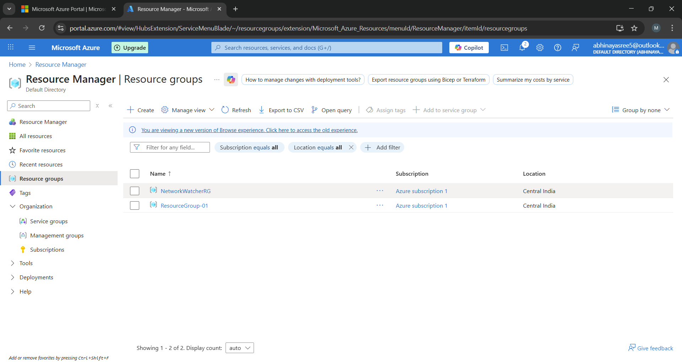

- Create a Virtual Network (VNet)
- Address space: 10.0.0.0/16

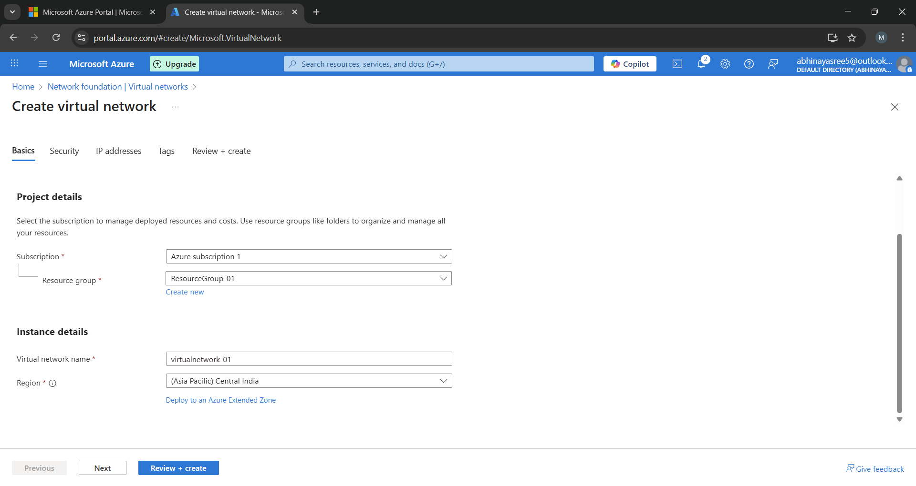

- Create two subnets:
- Web Subnet: 10.0.0.0/24
- AppSubnet: 10.0.1.0/24
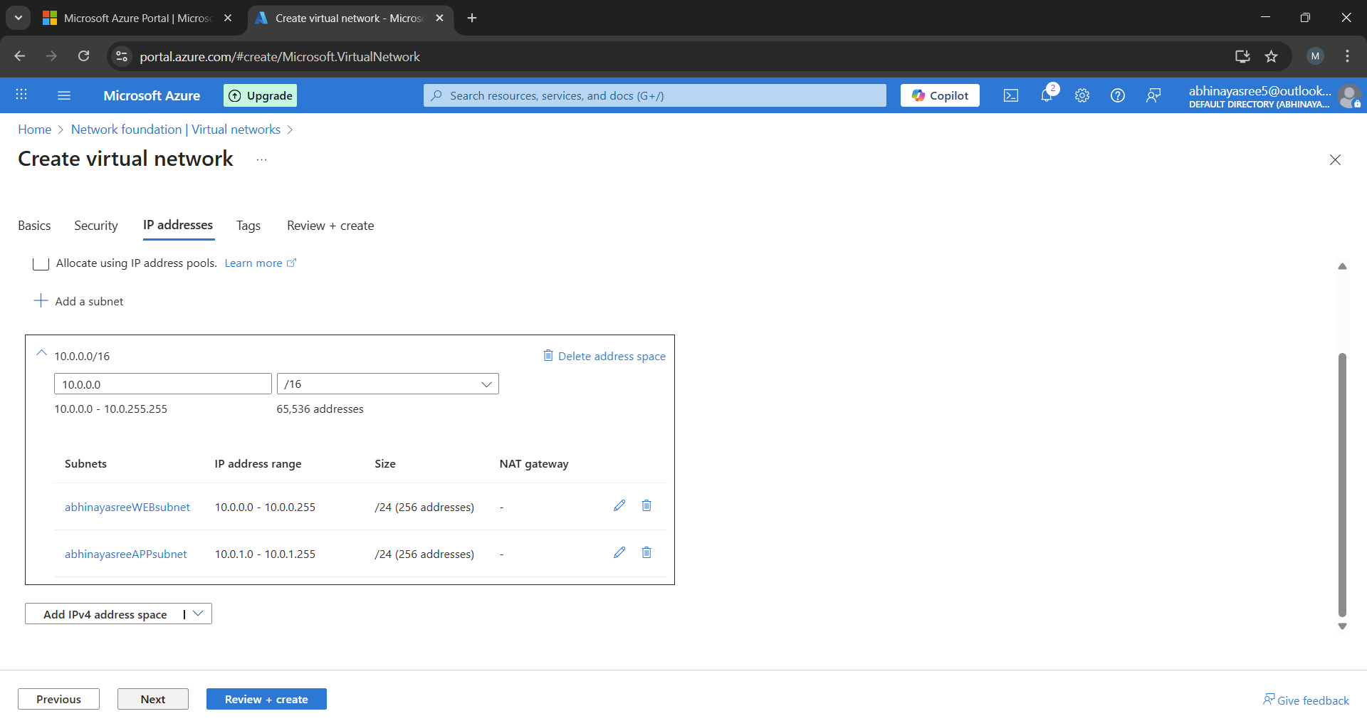
Create virtual network with two subnets

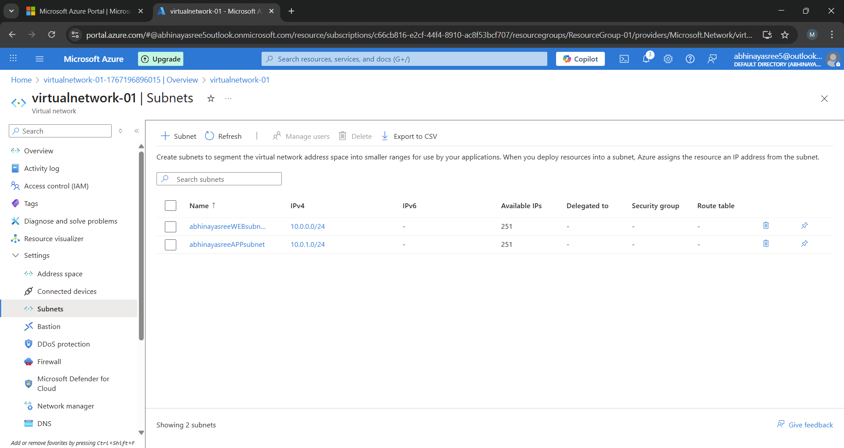
- Step 2: Create Web Virtual Machine (Web VM)
• OS: Linux (Ubuntu)
• Subnet: Web Subnet
• Public IP: Yes (for SSH access)
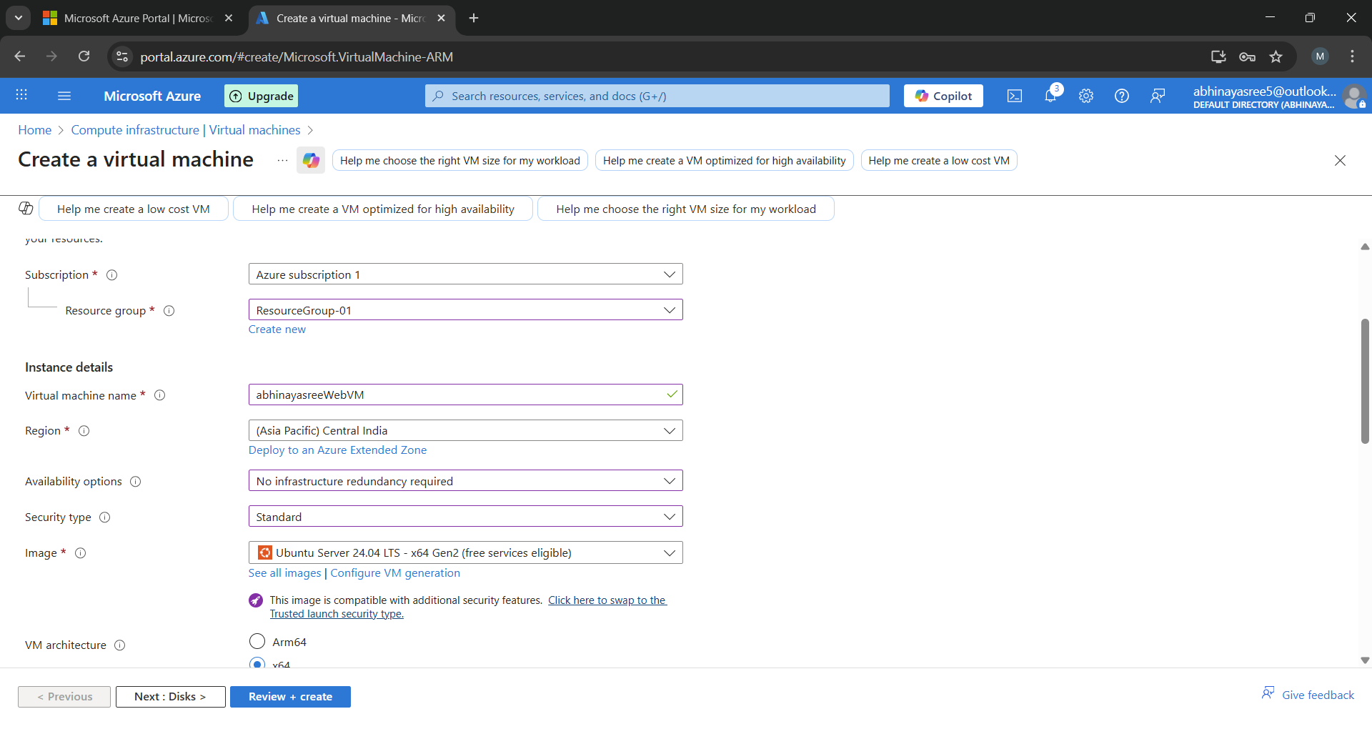
- Create virtual machine and allow public inbound rules HTTP (80), SSH (22)
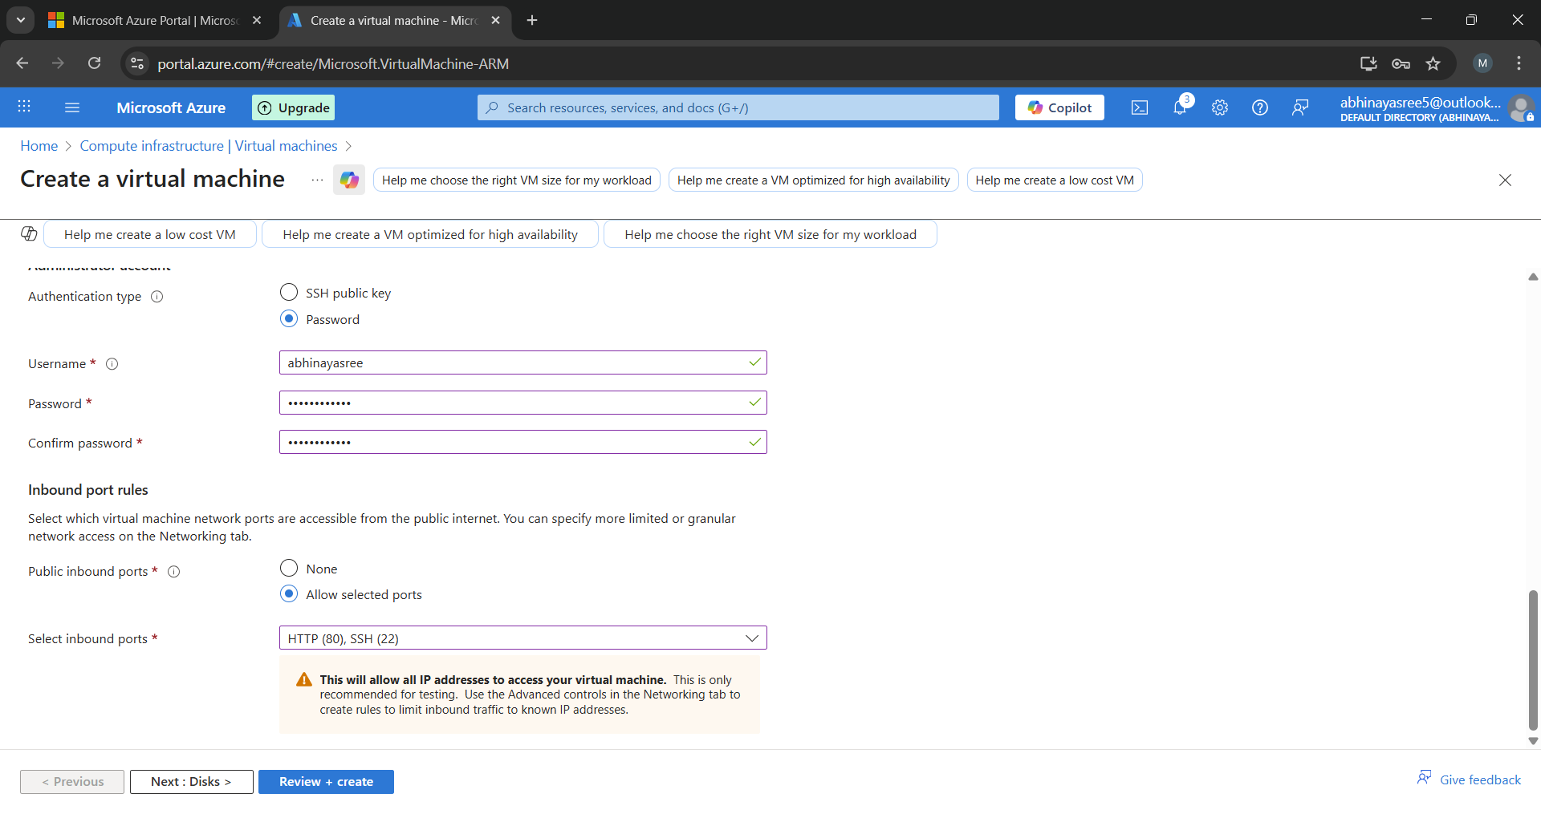
- And click on review + create
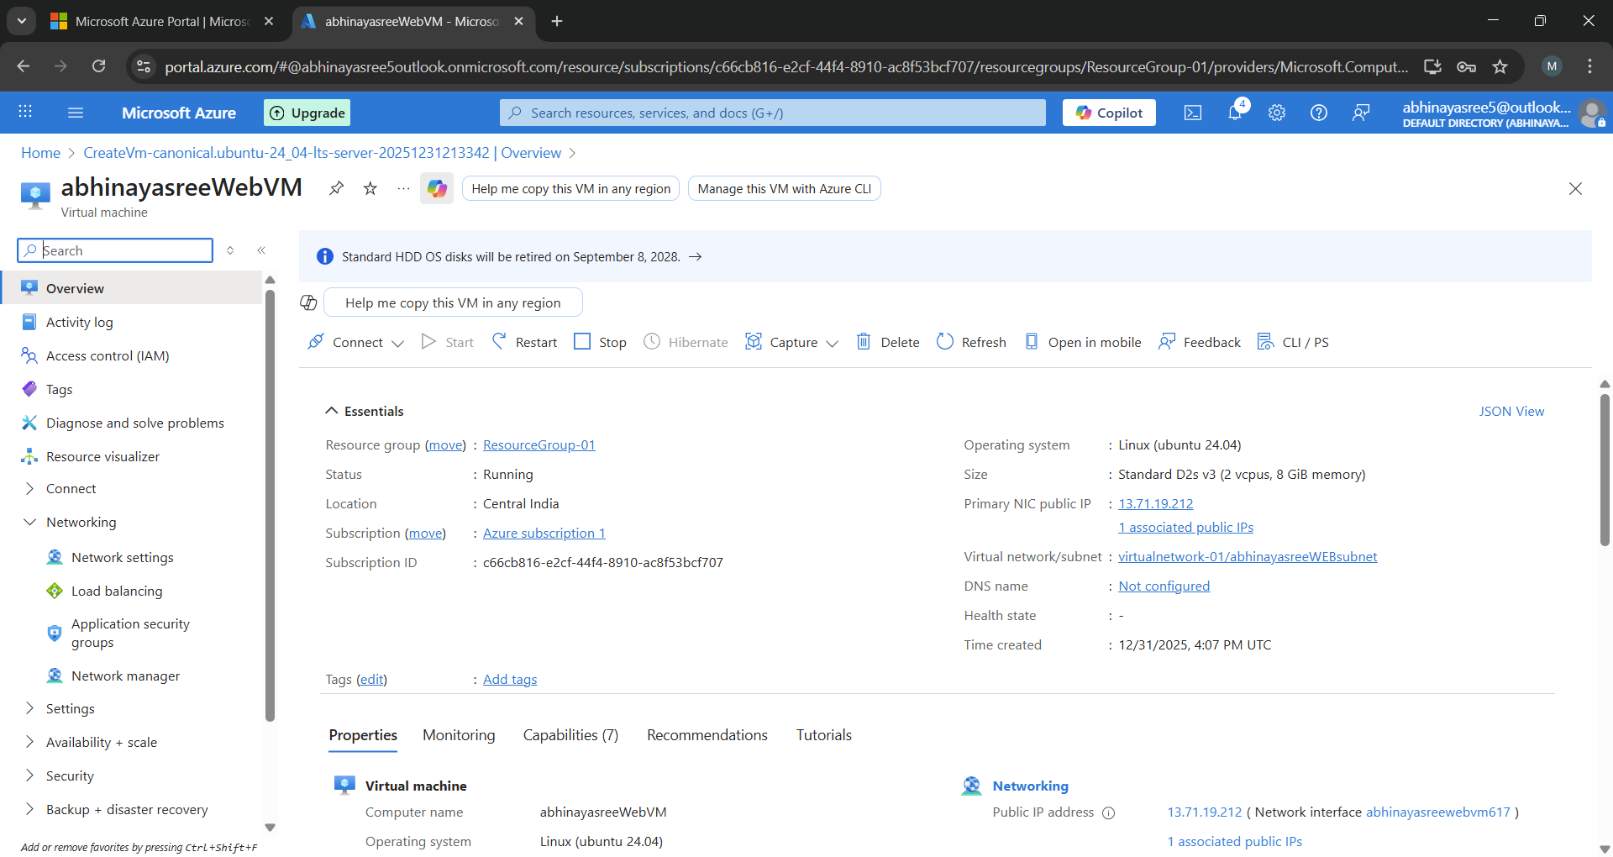
- Here the webVM is created in virtual network in web subnet
- Step 3: Install NGINX on Web VM
By using below commands install nginx in mobaxtrem
- Sudo su (to switch to root user)
- sudo apt update
- sudo apt install nginx -y
- sudo systemctl start nginx

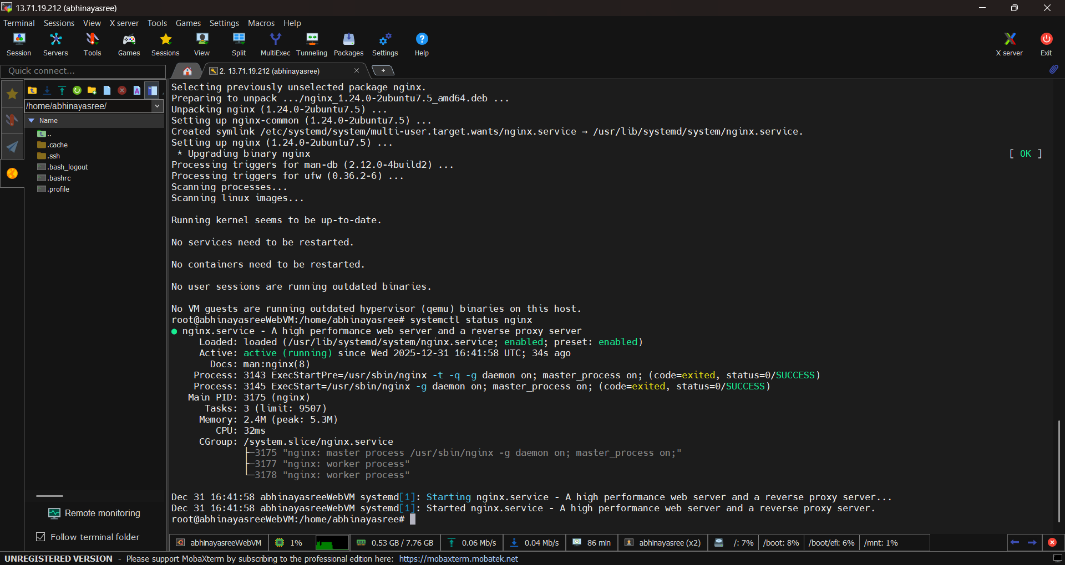
- The successful installation of NGINX was verified by checking the service status using the systemctl command, which showed the service as active and running in the above image.
- Verify NGINX:
    - Browse Web VM public IP
    - NGINX default page should be displayed

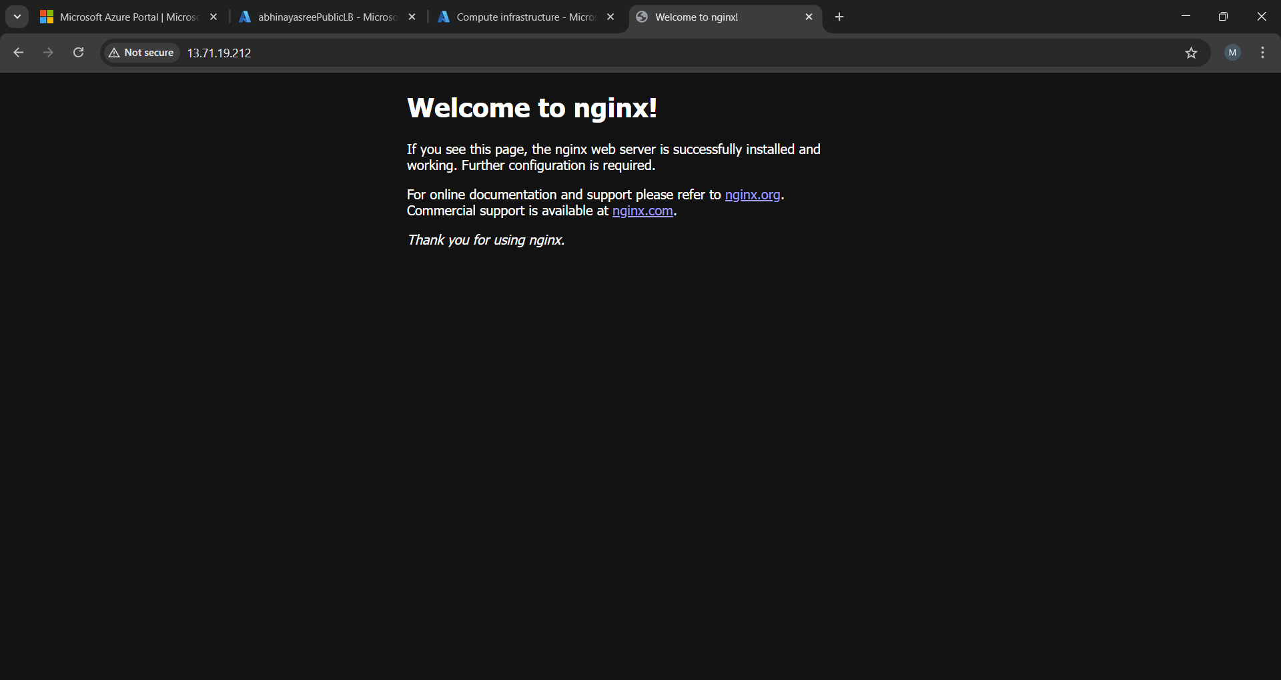

- Step 4: Create Application Virtual Machine (App VM)

- OS: Linux (Ubuntu)
- Subnet: App Subnet
- Public IP: Optional (recommended only for admin access)

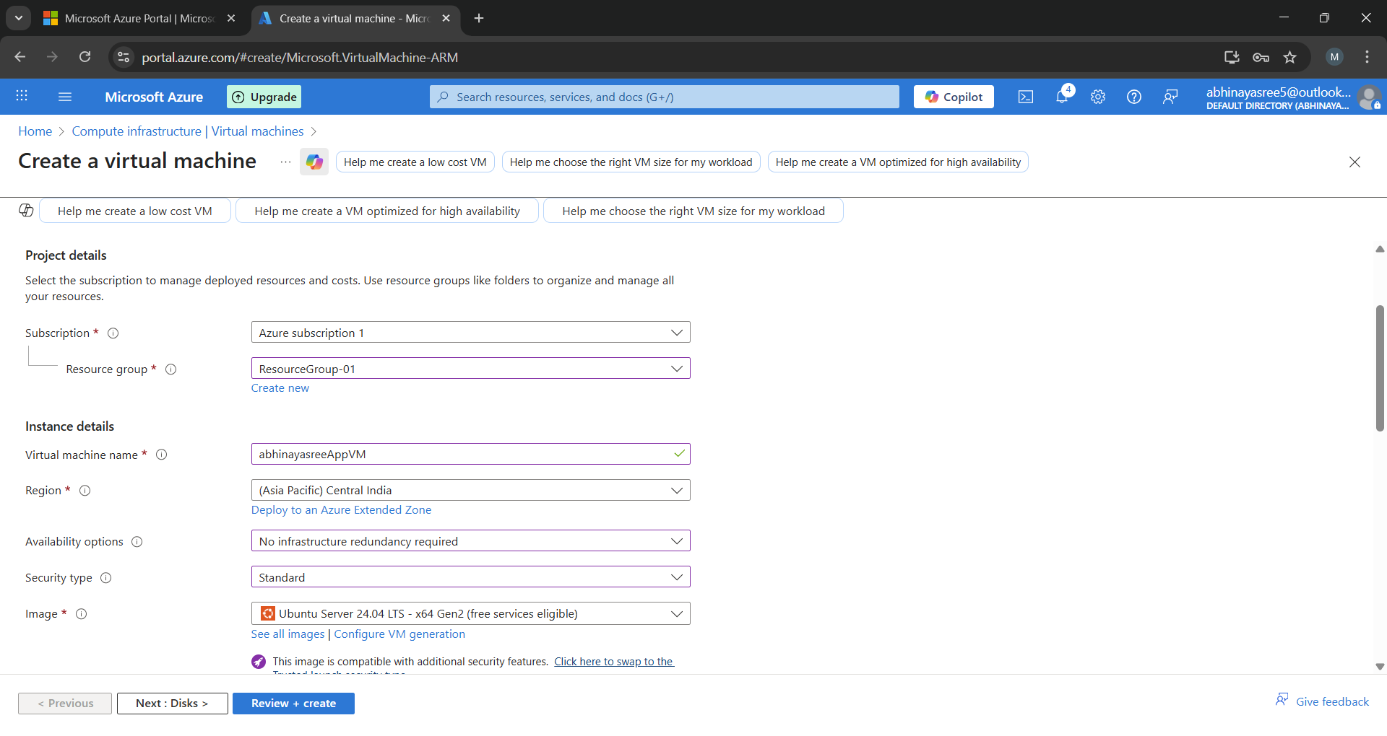
- Create app virtual machine and allow inbound rules SSH (22)
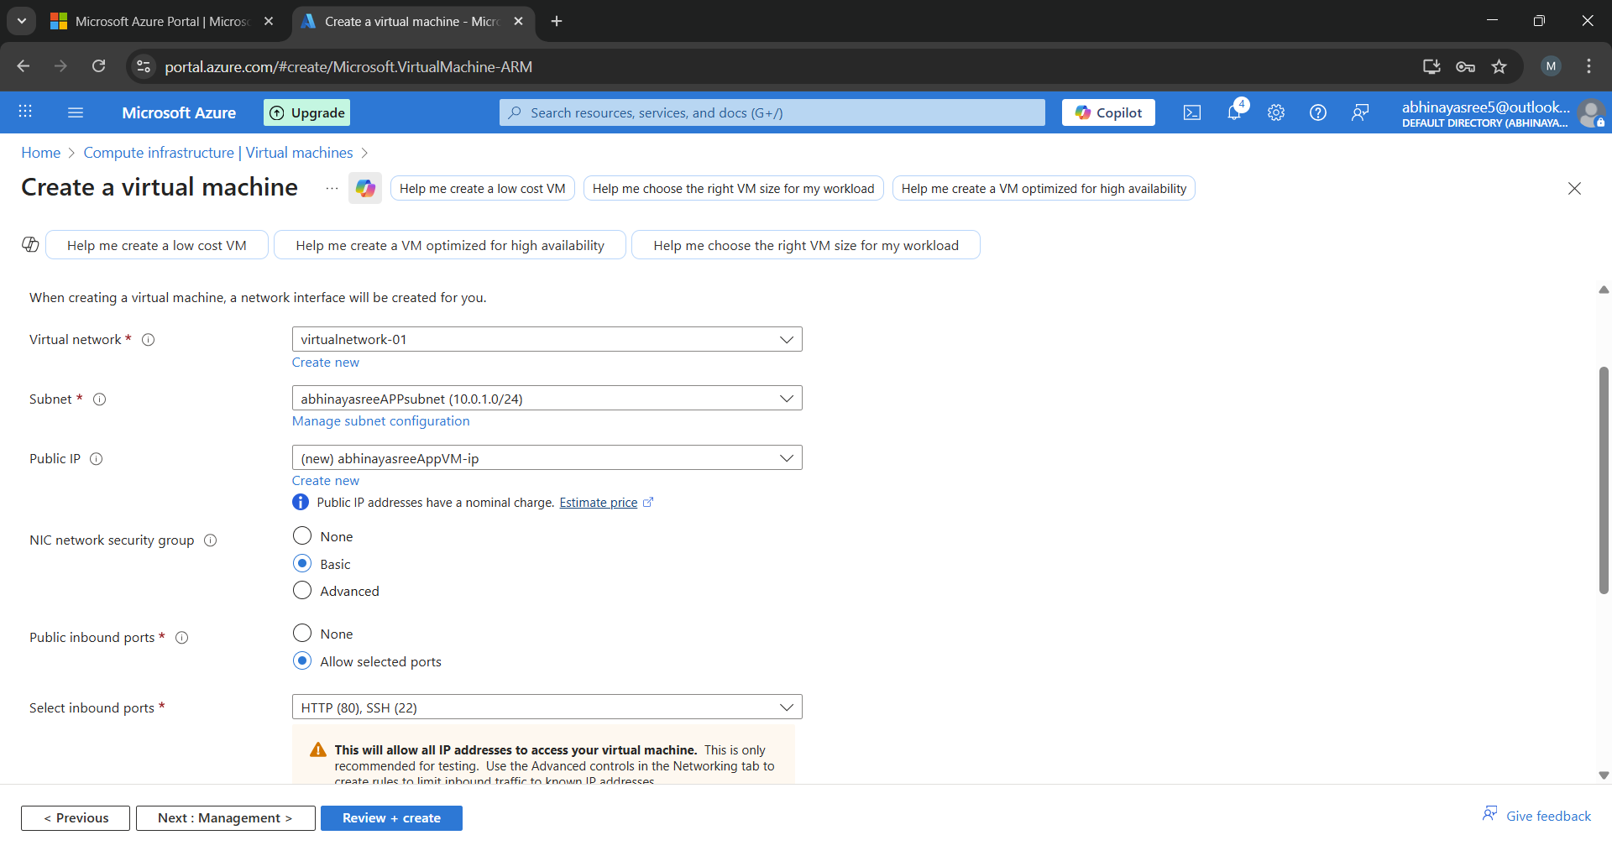
- Click on review + create

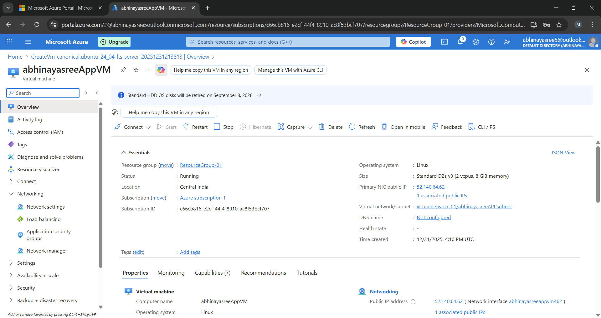
- Here the AppVM is created in virtual network in App subnet
- Step 5: Install Tomcat on App VM
By using below commands install Tomcat in mobaxterm

  - Sudo su (to switch to root user)
  - sudo apt update
  - sudo apt install openjdk-11-jdk -y
  - wget https://archive.apache.org/dist/tomcat/tomcat-9/v9.0.96/bin/apache-tomcat-9.0.96.tar.gz
  - tar -xvzf apache-tomcat-9.0.96.tar.gz
  - cd apache-tomcat-9.0.96
  - ls
  - cd bin
  - ./startup.sh

- Apache Tomcat was successfully installed and started, and the default Tomcat welcome page was verified by accessing it via the VM public IP on port 8080.

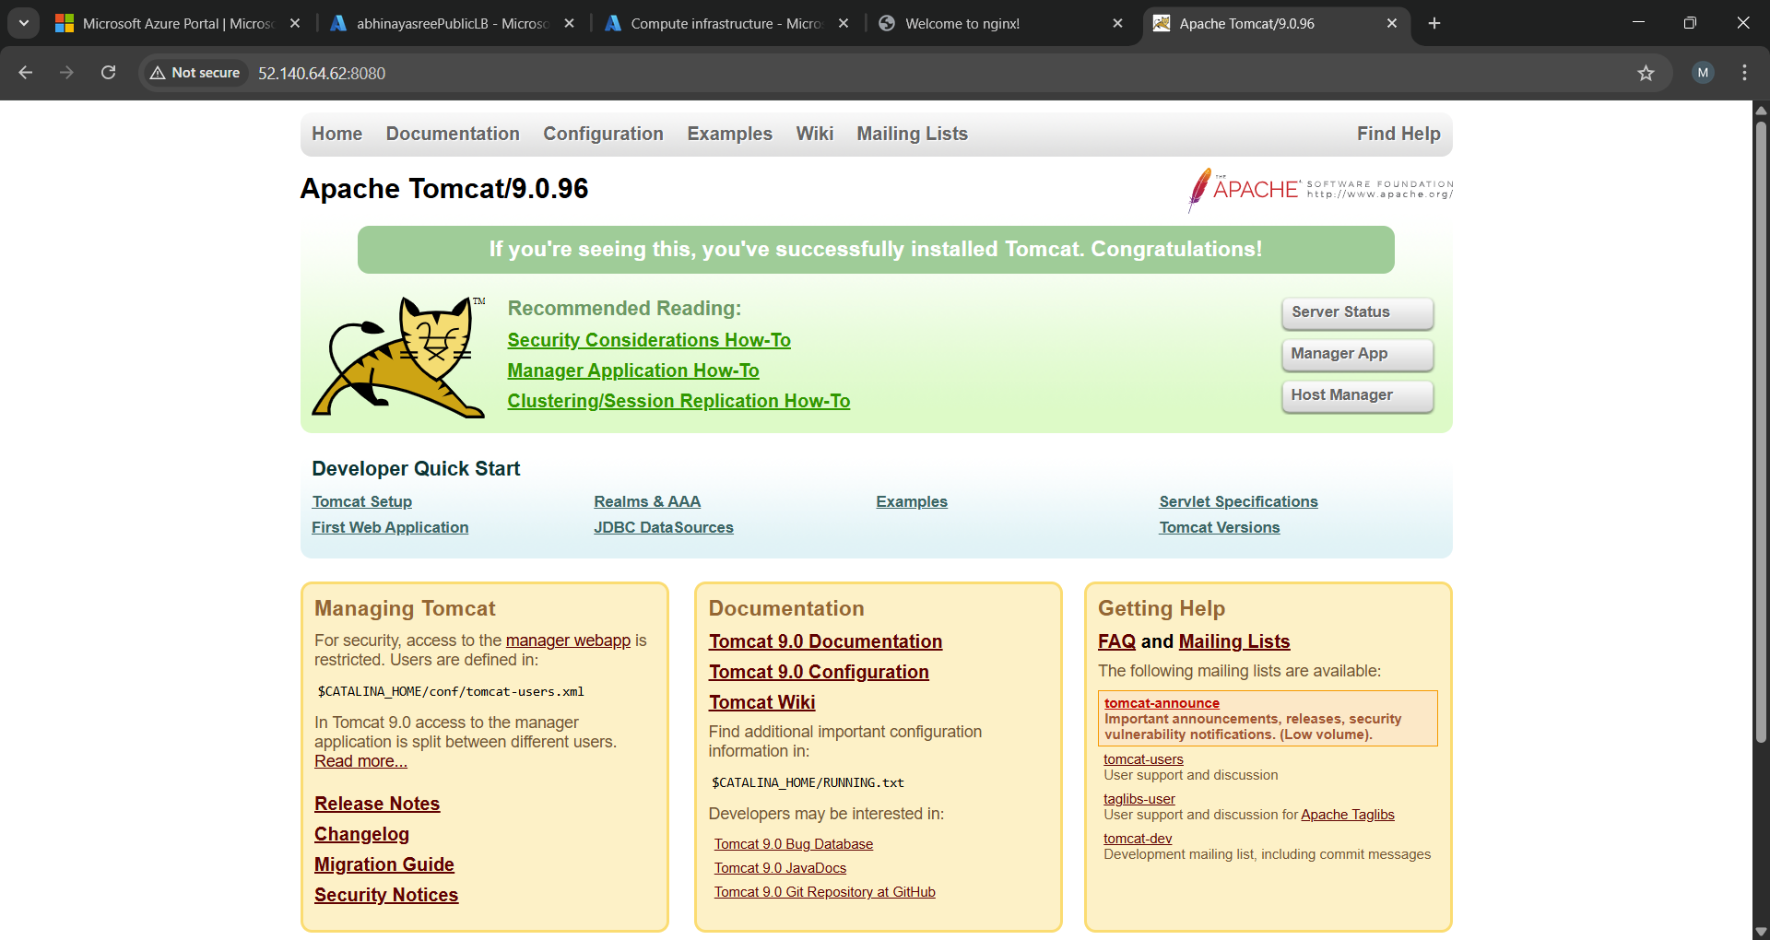
- Step 5: Create Azure Public Load Balancer
- Create Public Load Balancer
- Select standard load balancer
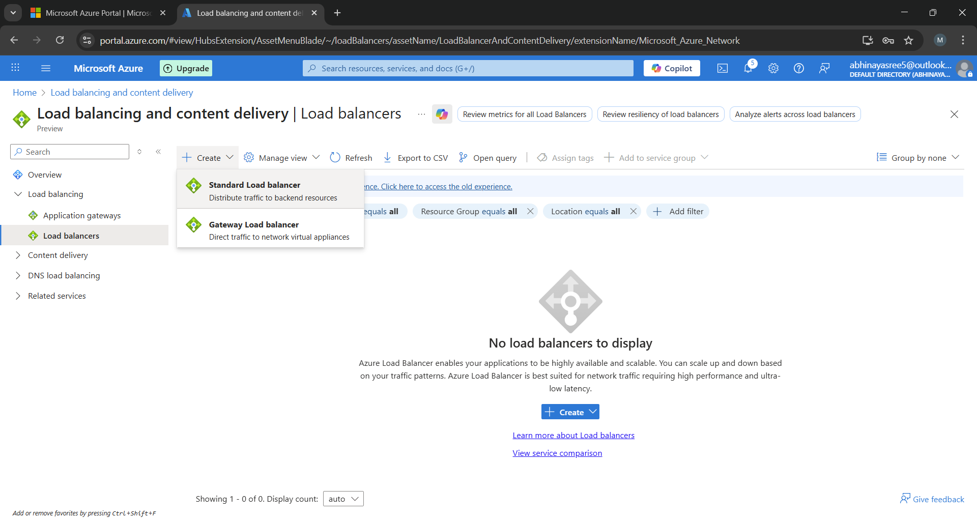

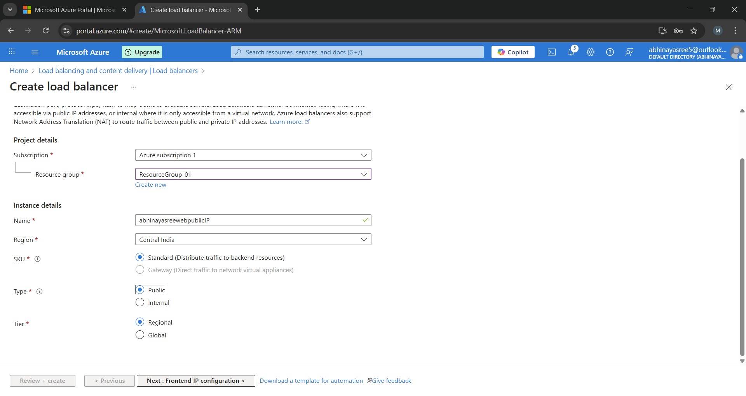
- Here the type should be Public because it is public load balancer
- Frontend IP Configuration:
  - Public IP address
- Backend Pool:
  - Add Web VM
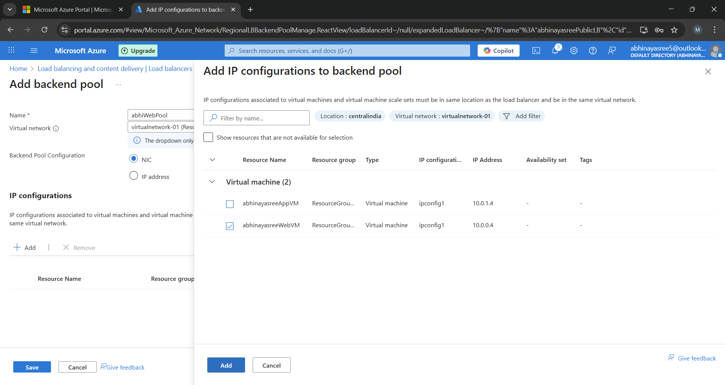

- Health Probe:
  - Protocol: TCP
  - Port: 80
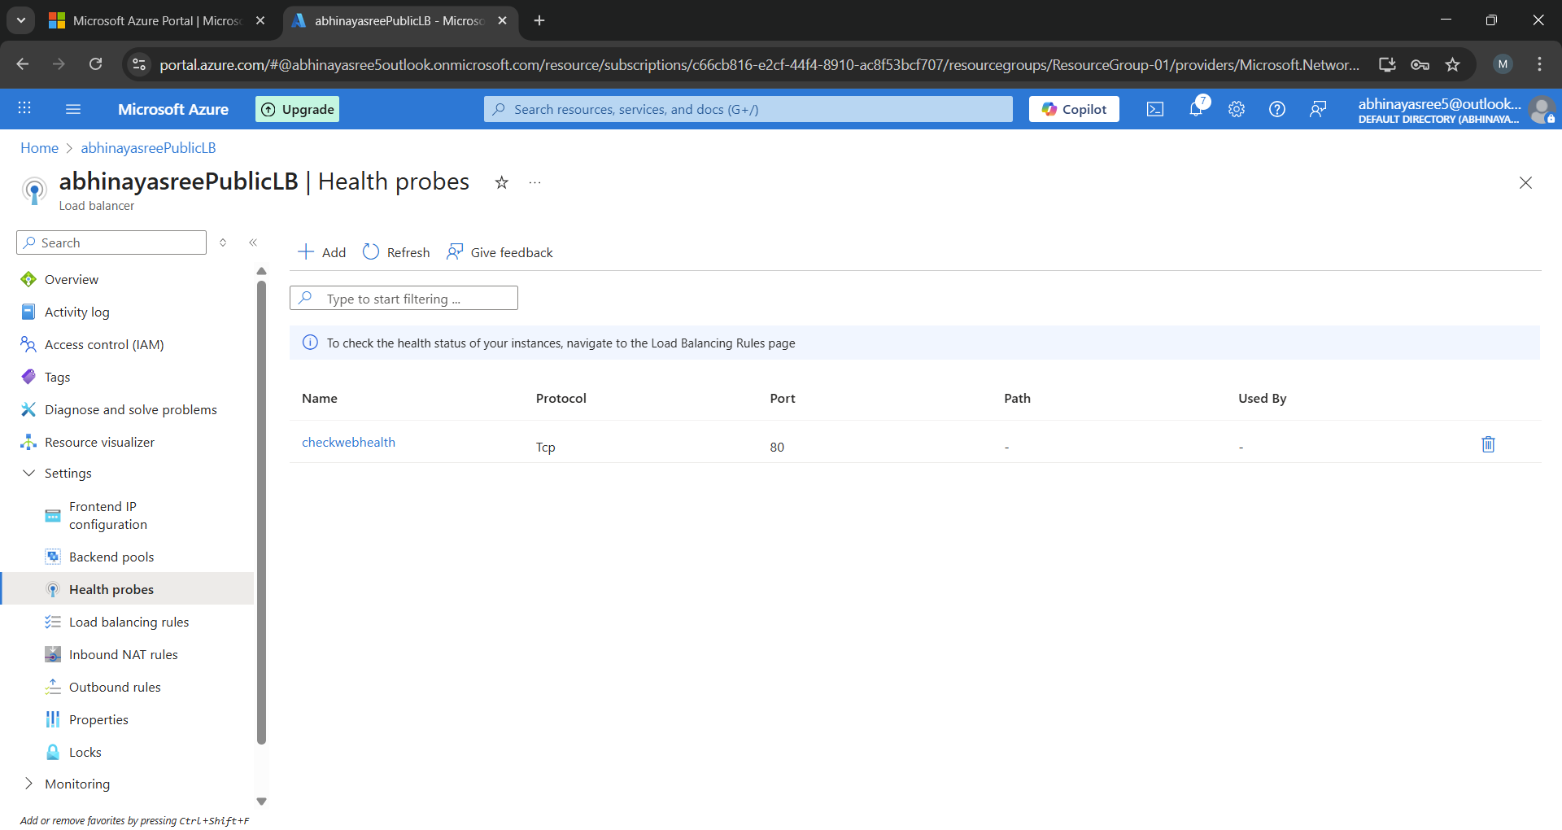
- Load Balancing Rule:
- Frontend Port: 80
- Backend Port: 80
- Backend Pool: Web VM
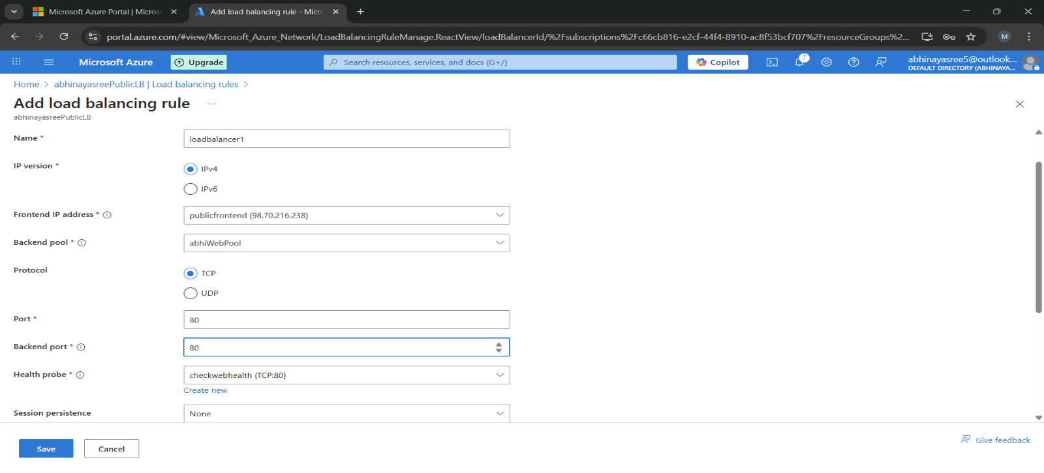
- After saving you can see public load balancer
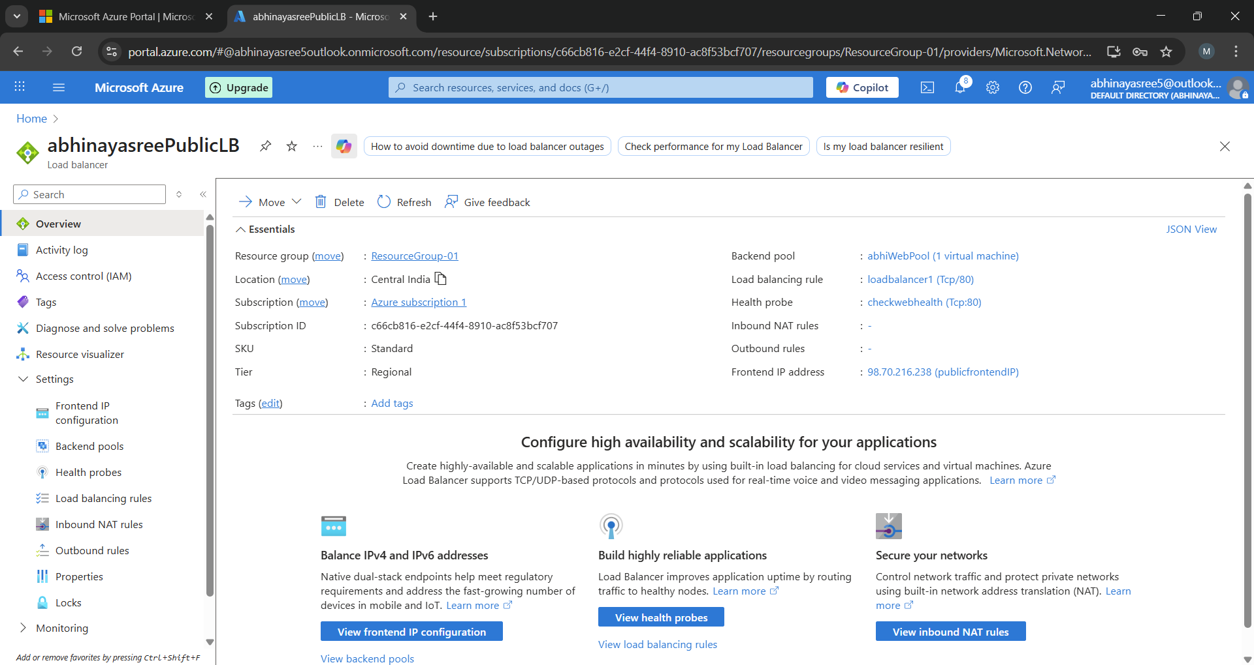
- Step 6: Create Azure Private Load Balancer
- Create Private Load Balancer
- Frontend IP Configuration:
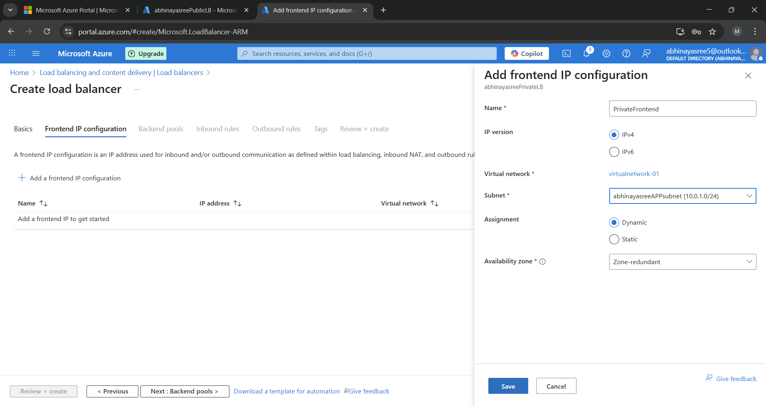

    - Private IP from AppSubnet

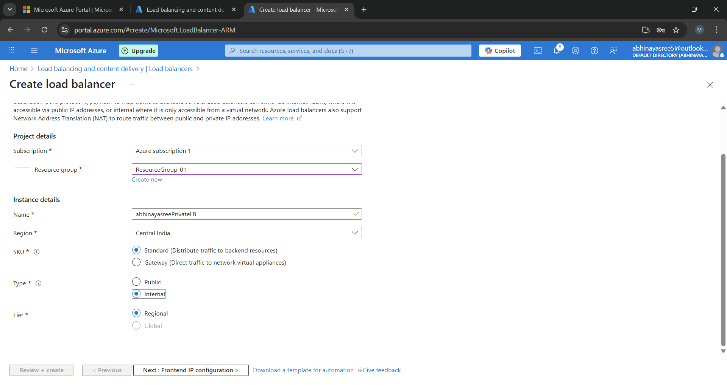
    - Here the type should be internal because it is private load balancer
- Backend Pool:
    - Add App VM
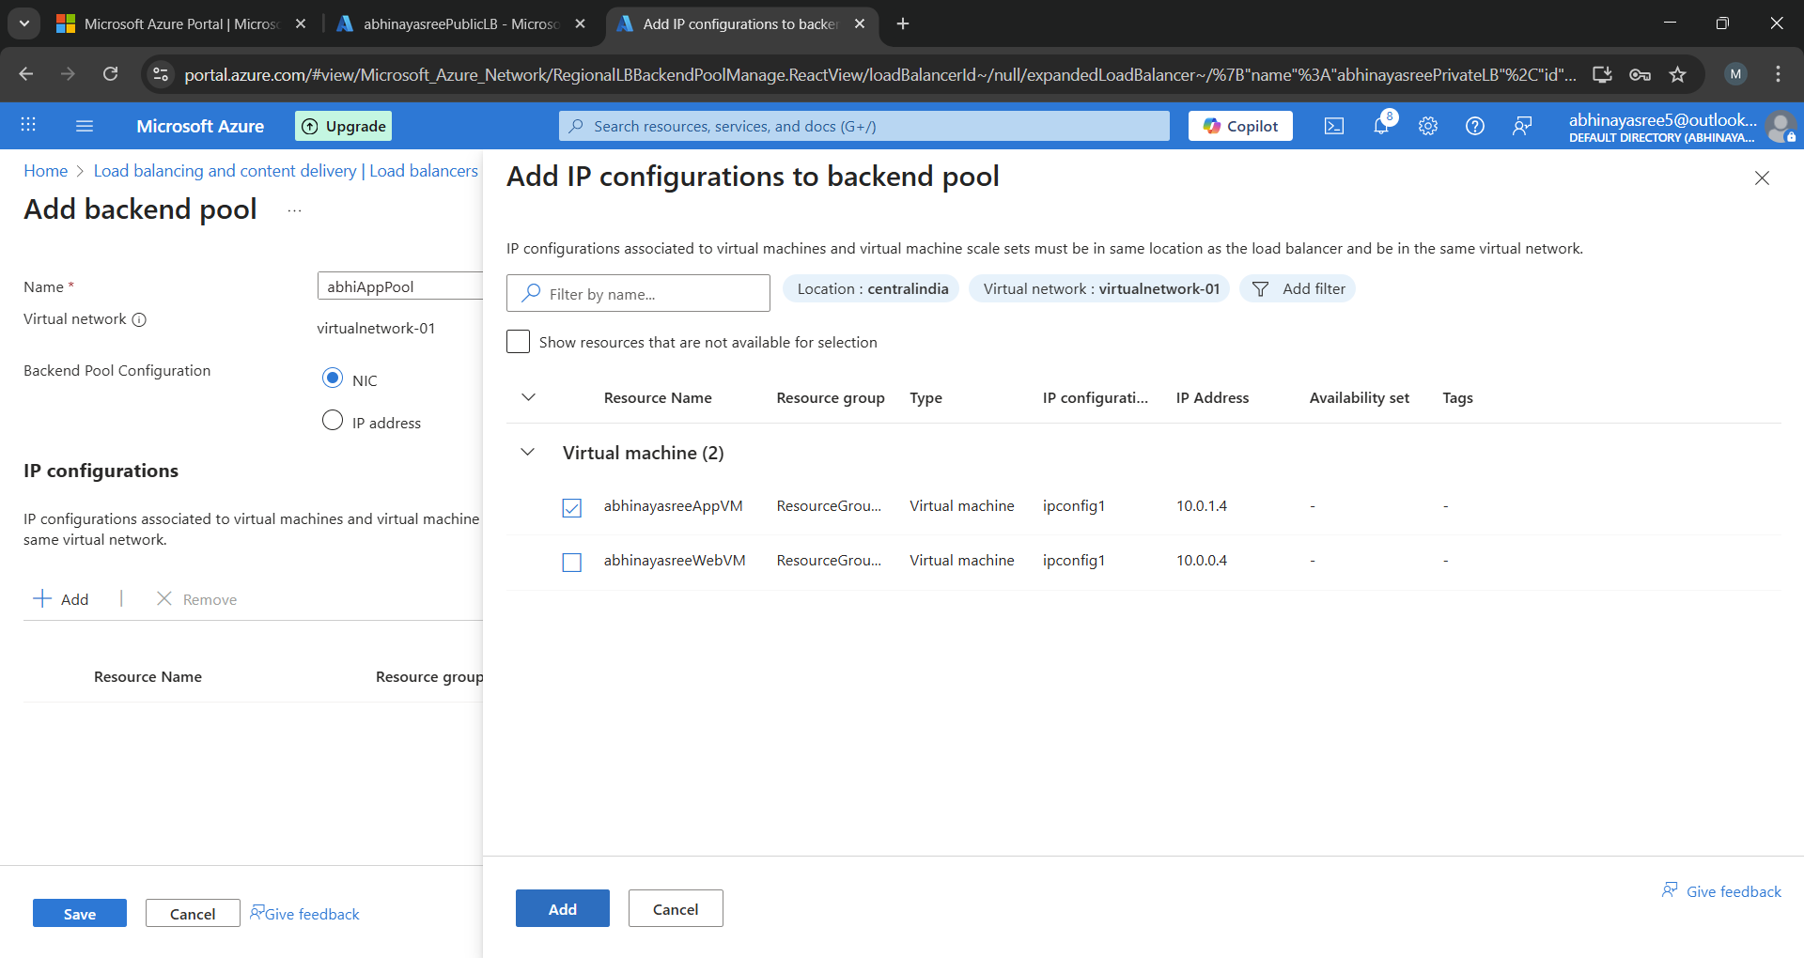

- Health Probe:
    - Protocol: TCP
    - Port: 8080

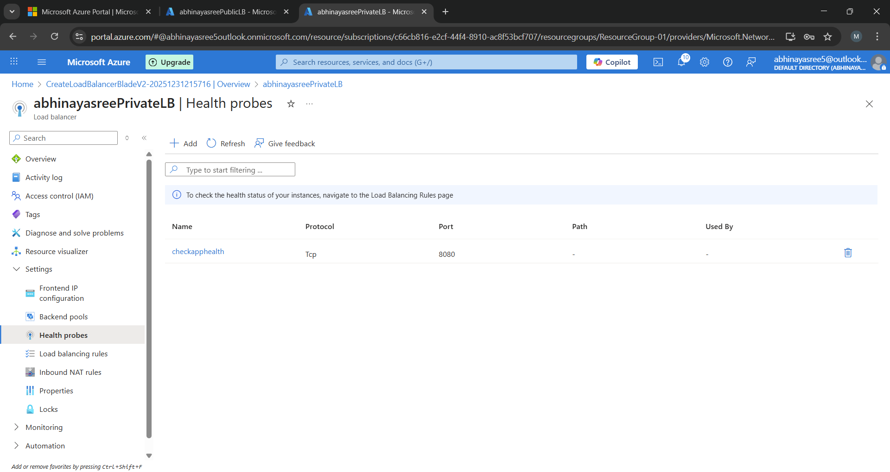

- Load Balancing Rule:
- Frontend Port: 8080
- Backend Port: 8080
- Backend Pool: App VM

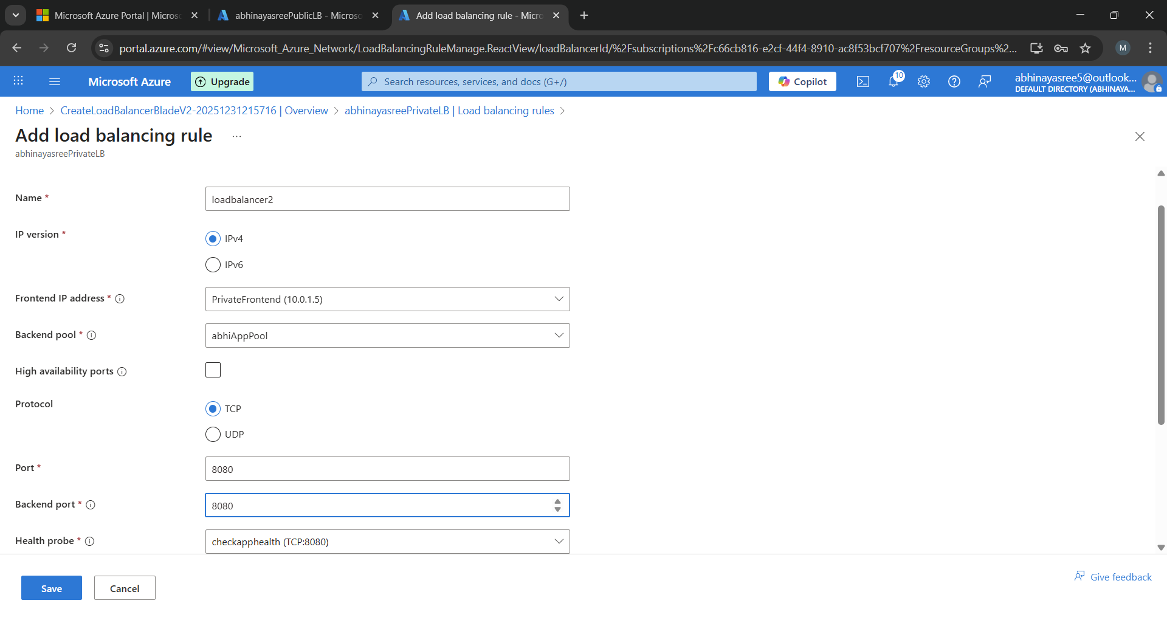
- After saving you can see private load balancer
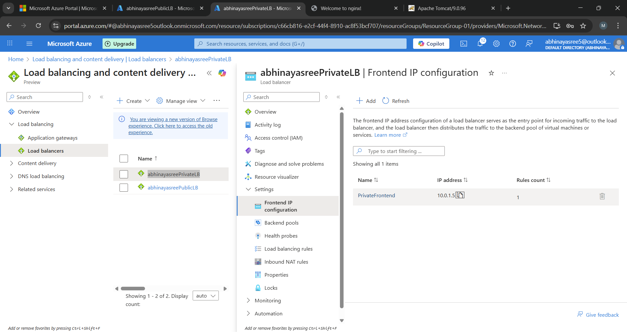

- Step 7: Connectivity Testing (Main Validation Step)

Test from Web VM to Private Load Balancer
    - Connect to Web VM using SSH

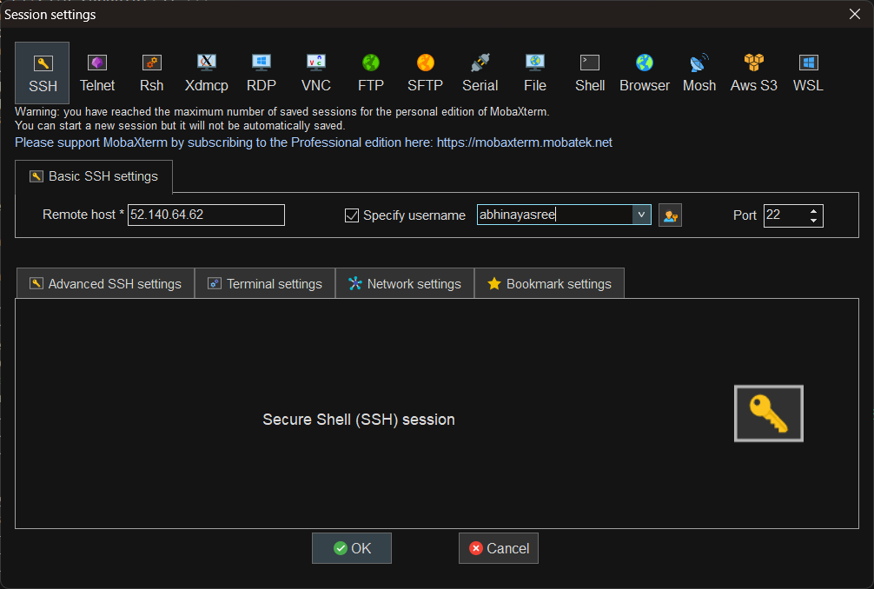

    - Give webvm public Ip and username.
    - Run telnet command.

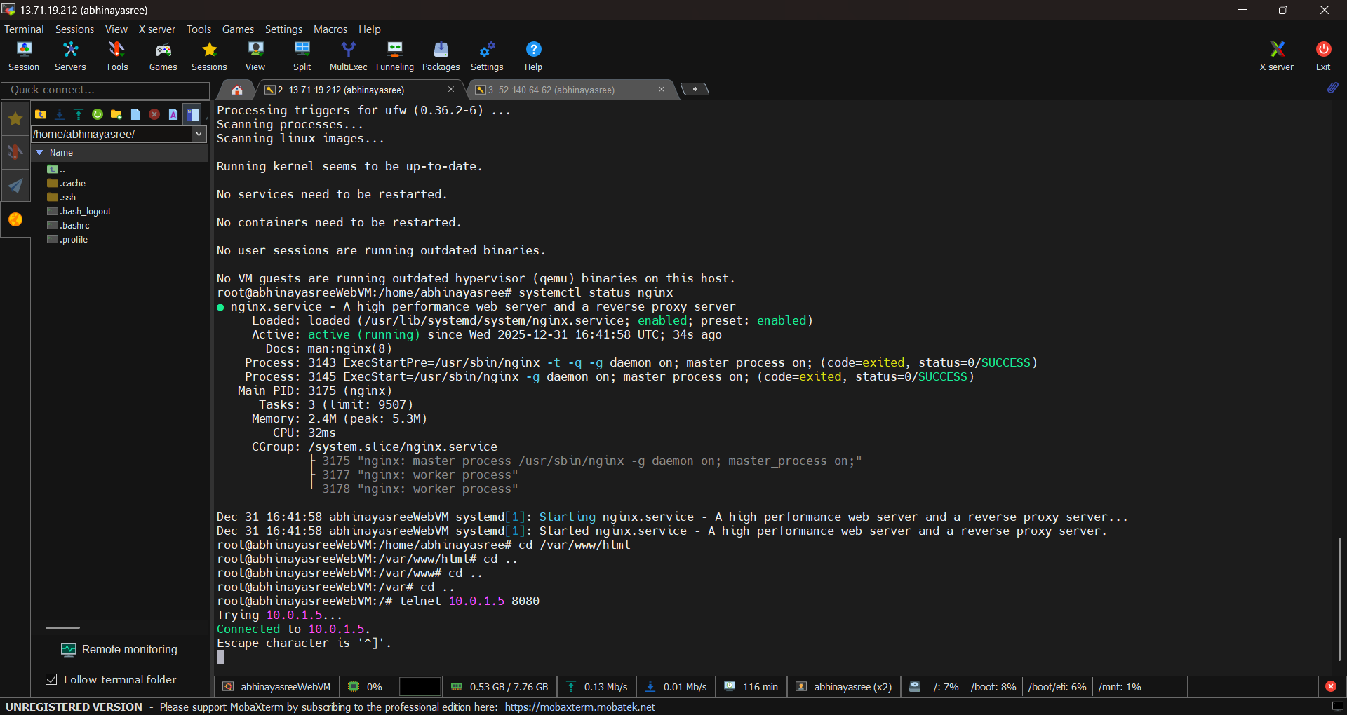
This confirms:
- Web VM can reach App VM through Private Load Balancer.
- Internal traffic flow is working correctly.

- Security Validation

- Tomcat is not exposed publicly.
- Only Private Load Balancer IP is accessible from Web VM.
- Application layer is protected inside the VNet.
- End users cannot directly access Tomcat from the internet.
- This prevents unauthorized external access to the application layer.
- External traffic cannot reach the Private Load Balancer.
- Only the Web VM (NGINX) is exposed through the Public Load Balancer.
- Backend Application services remain isolated from the internet.

- Conclusion:

In this project, we successfully implemented Azure Public and Private Load Balancers to design a secure two-tier architecture. The Public Load Balancer exposes the Web layer (NGINX) to the internet, while the Private Load Balancer ensures secure internal communication with the Application layer (Tomcat). Connectivity was validated using telnet, confirming proper backend pool configuration and network security. This architecture follows real-time industry best practices for scalability, security, and high availability.

